**Ganpat University**

**Faculty of Engineering & Technology**

**Computer Science & Engineering**

**(2CSE204) Basics of Operating System and Shell Scripting**

**Practical 4**

***Name:- Dwij Vatsal Desai***

***Sem:- 2***

***Sub: - BOSS***

***Enrollment No.:- 23162121027***

***Prac:- 4***

***Date:- 3/3/2024***

1. List the directories and files present at /var/log and its output should be stored in

/tmp/yourname/prac41 file.

**Command:-** ls -la /var/log > /tmp/dwij/prac41

cat /tmp/dwij/prac41

**Image:-**

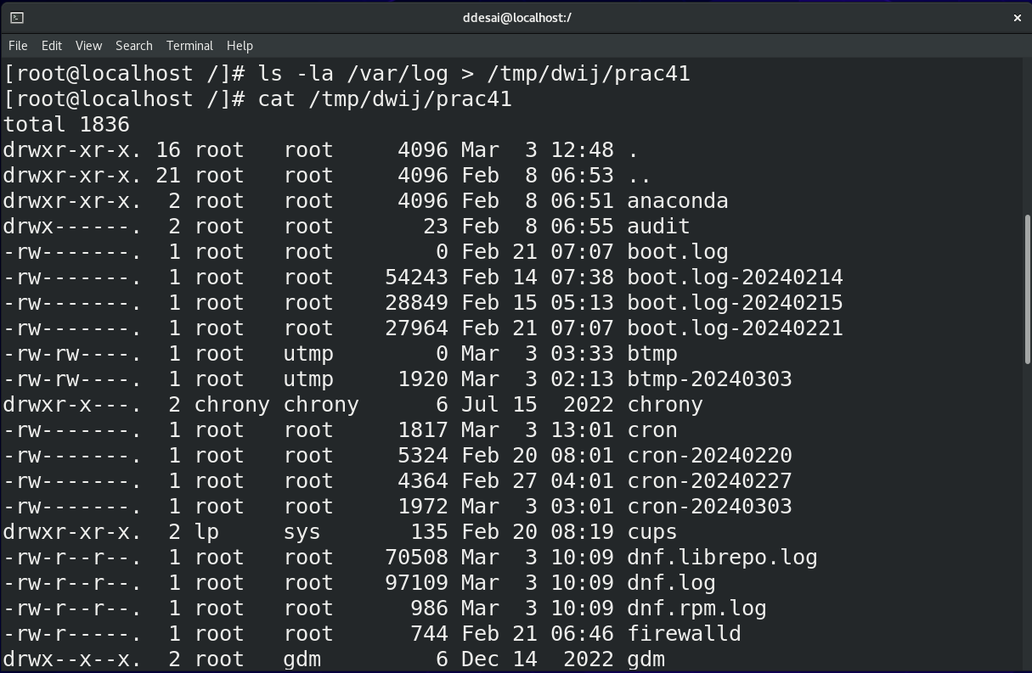

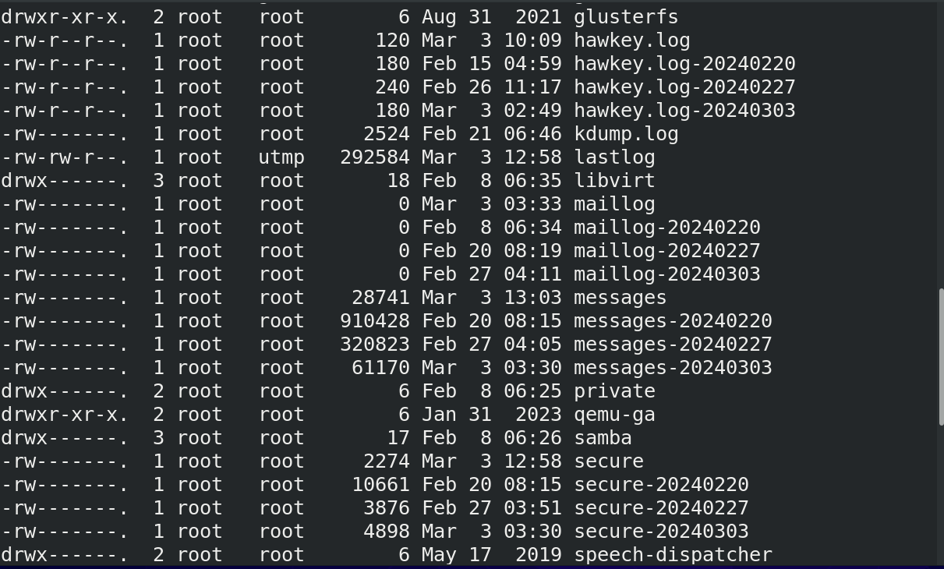 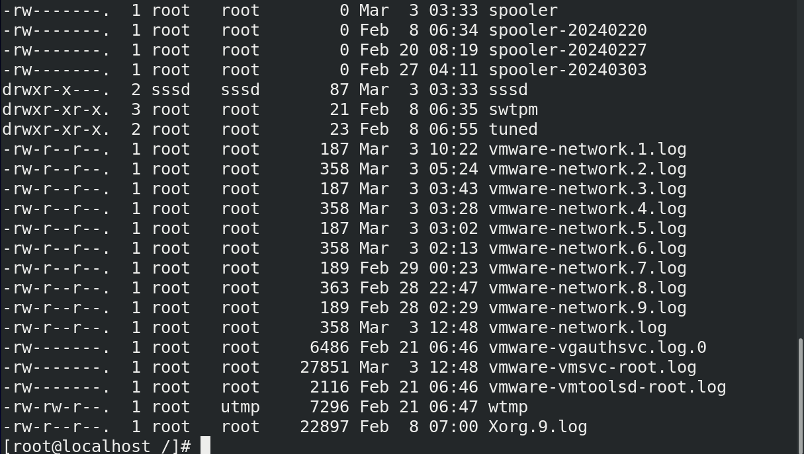

1. Store the first 10 lines of /etc/passwd file in /tmp/yourname/prac42 file and also display the last 5 lines from those 10 lines on terminal. Both the operations should execute at the same time.

**Command:-** head -n 10 /etc/passwd | tee /tmp/dwij/prac41 | tail -n 5

**Image:-**

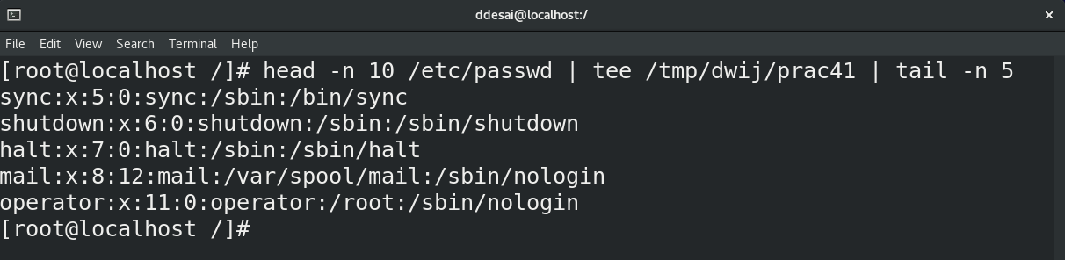

1. List all the files and directories present in /etc directory whose name starts with a, c and e. This output should be stored in /tmp/yourname/prac33 in such a way that previous content of the file does not get affected.

**Command:-** ls -R youname

**Image:-**

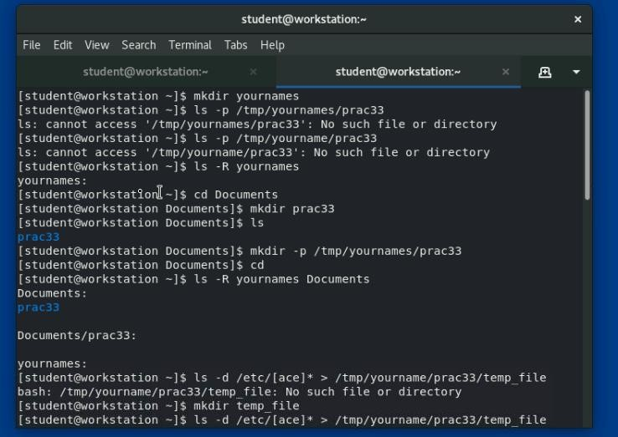

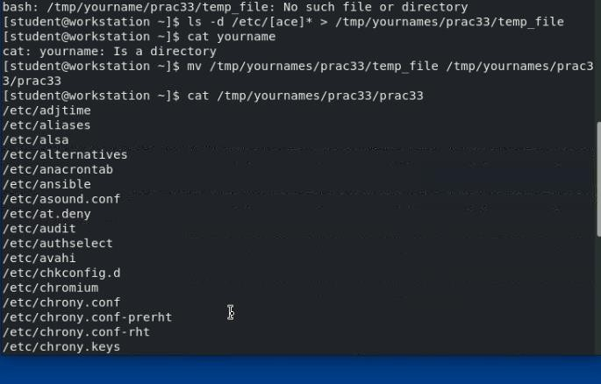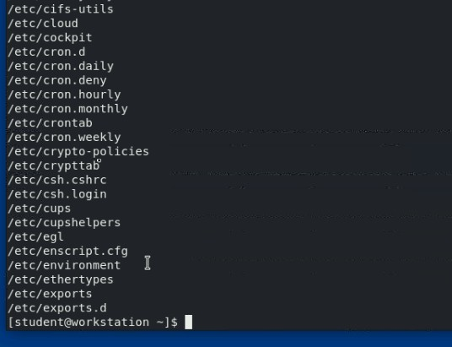

1. Generate some error by using false command but that error should neither be displayed on terminal nor stored in any file.

**Command:-** false > /dev/null

**Image:-**

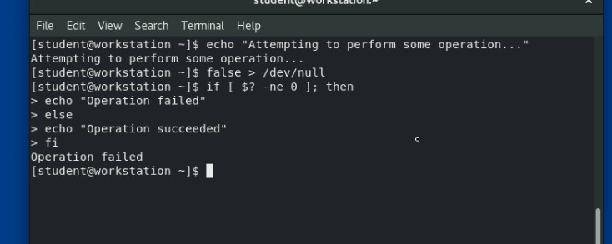

1. Demonstrate the usage of shell and environment variables with a suitable example.

**Command:-** export COMPANY=”ABC Corporation”

**Image:-**

